Creating a smart parking system using IoT involves several components, including sensors to detect parking space occupancy, a microcontroller to process data, and a cloud-based platform for monitoring and control. Here's a simplified block diagram of a smart parking system using IoT:

**CIRCUIT DIAGRAM:**

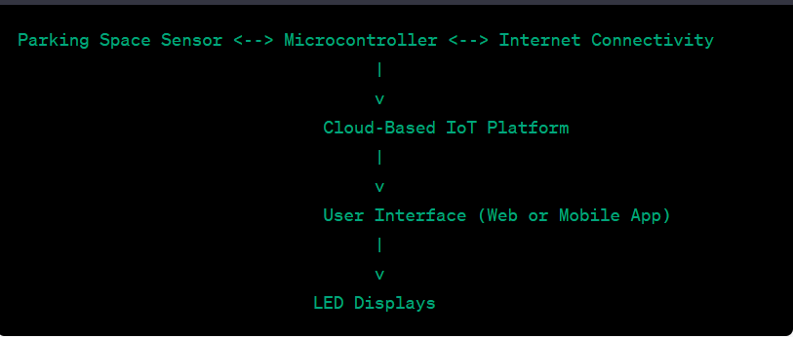

**Components**:

* **Parking Space Sensors**: These can be ultrasonic or infrared sensors placed in each parking space to detect the presence of a vehicle.
* **Microcontroller (e.g., Arduino or Raspberry Pi):** The microcontroller collects data from the sensors, processes it, and communicates with the cloud platform. It can also control LED displays to indicate parking space availability.
* **Internet Connectivity**: The microcontroller is connected to the internet via Ethernet, Wi-Fi, or cellular data.
* **Cloud-Based Platform**: This is where all the data is collected, analyzed, and made accessible to users via a web or mobile application. It also provides real-time monitoring and control.
* **User Interface**: Users can access parking space availability information through a web or mobile app.
* **LED Displays**: These can be placed at the entrance of the parking area to indicate the availability of parking spaces. Green for available and red for occupied, for example.

**Flow of Operation**:

* Parking Space Sensors continuously monitor their respective parking spaces.
* When a vehicle occupies or vacates a parking space, the sensor sends this information to the microcontroller.
* The microcontroller processes this information and sends it to the cloud-based platform.
* The cloud-based platform updates the parking space availability status in real-time and makes it accessible to users through a user interface (app or web).
* Users can check parking availability using the app and navigate to the nearest available parking space.

.